* How to detach root volume from instance and attach another volume as a root volume.

1. First of all we have to create a instance in any region .

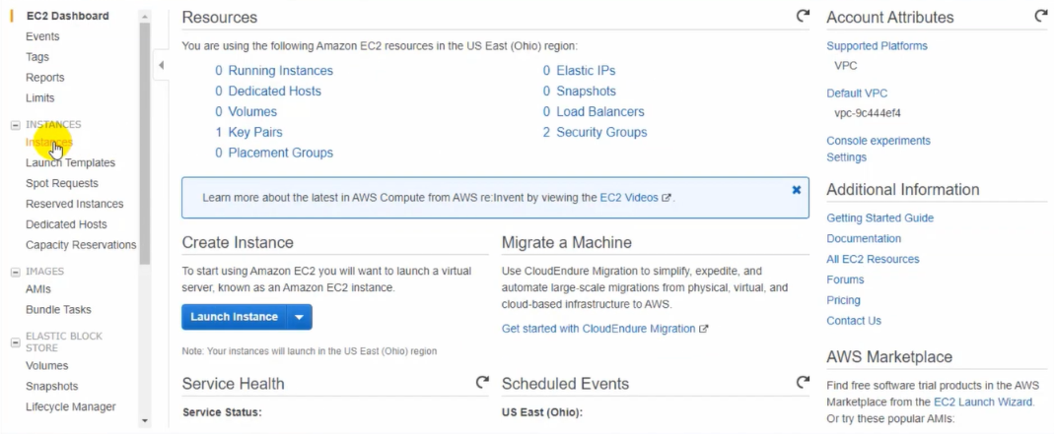

Here i open amazon service choose EC2 and launch instance, selected windows server 2012 R2 base.

2.In this step i go for configuration to the instance and i choose T2 micro.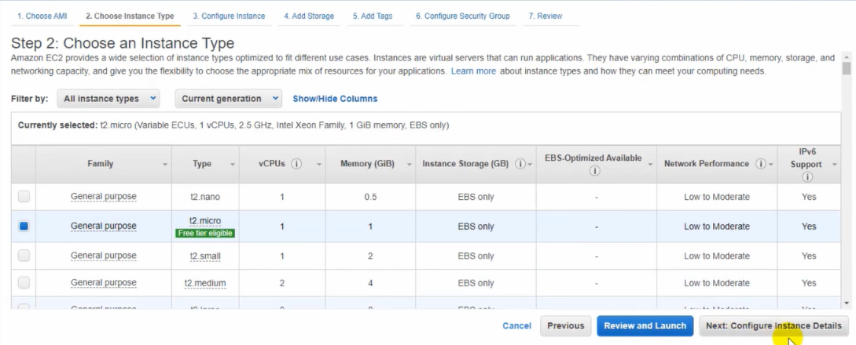

3.In this step i configure instance type.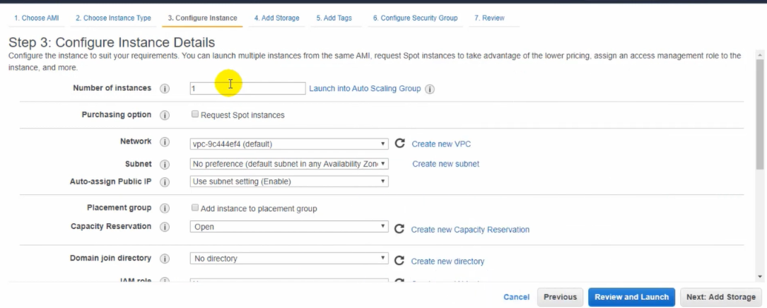

I choose as default 1 instance,vpc as default and subnet too.

4.In step four add root volume.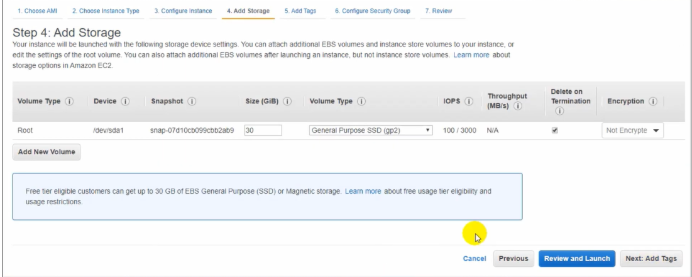

There is root volume size of 30gb as default, i can extend but amazon can take extra charge for it. Volume type general purpose ssd gp2. Here i can encrypt & unencrypt this volume.

After to configure this all i go for add tag.

5.In this step add tag but it optional i can add tag after launch the instance.

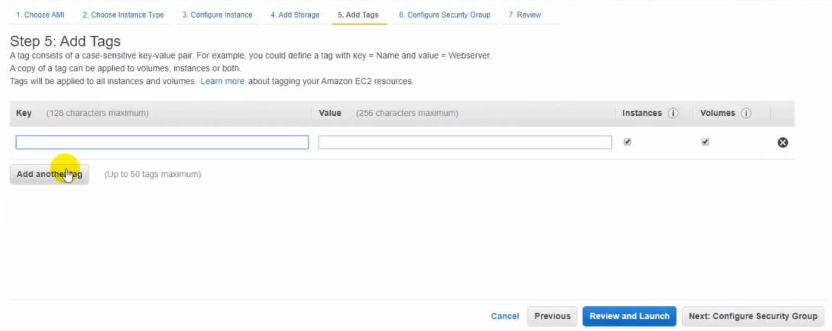

6.I configure security group DMZ-SERVER.

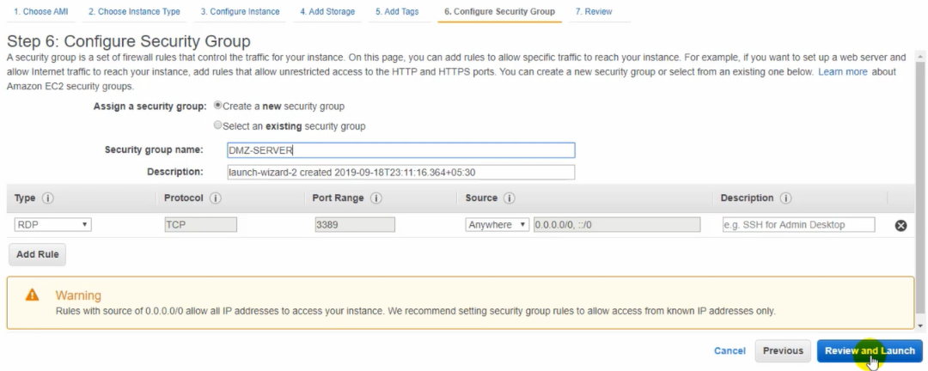

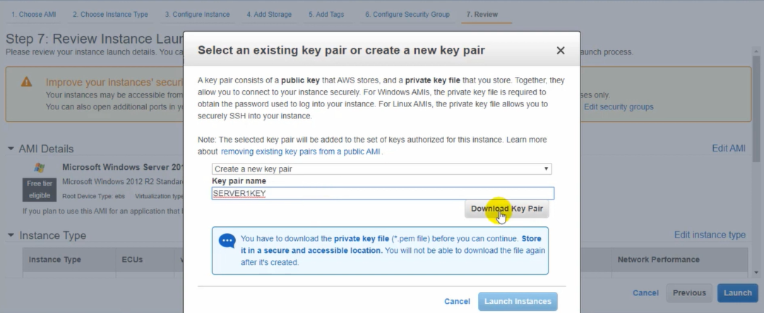

7.I launch instance and make a keypair and download it then launch.

8.It successfully launched and i click view instance.

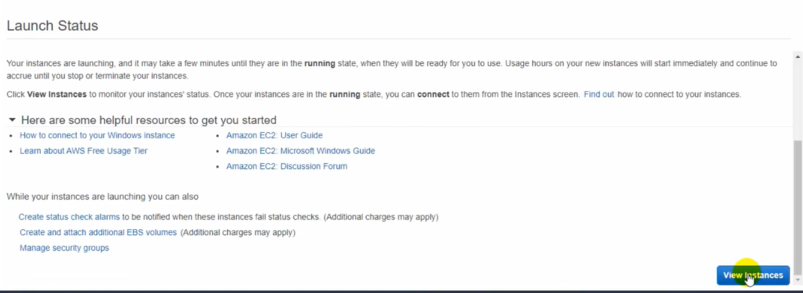

9.Here we can see the status of instance it checked 2/2 and it running condition.

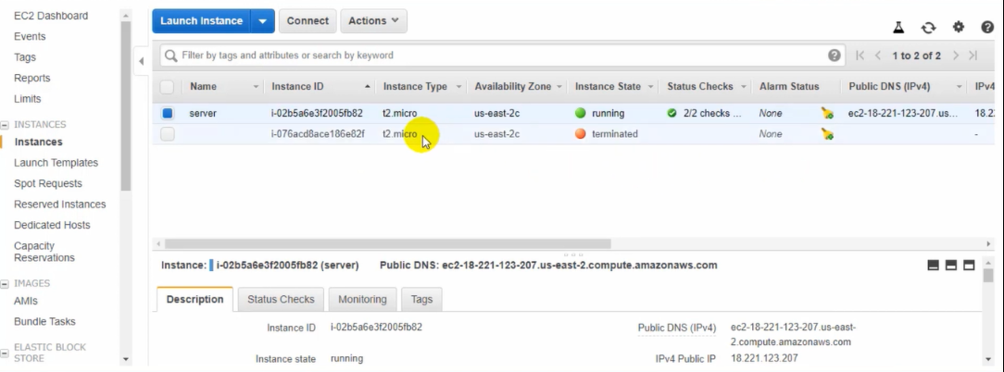

10.I connect it and take rdp to our server.

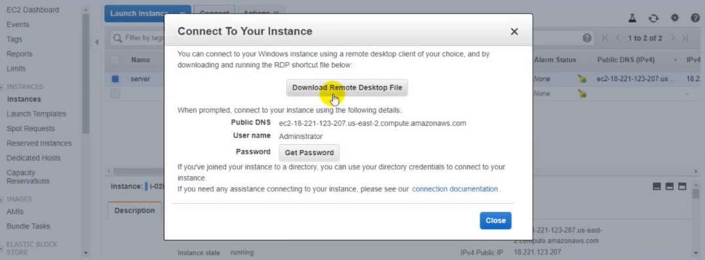

11.Now we can see it successfully connected.

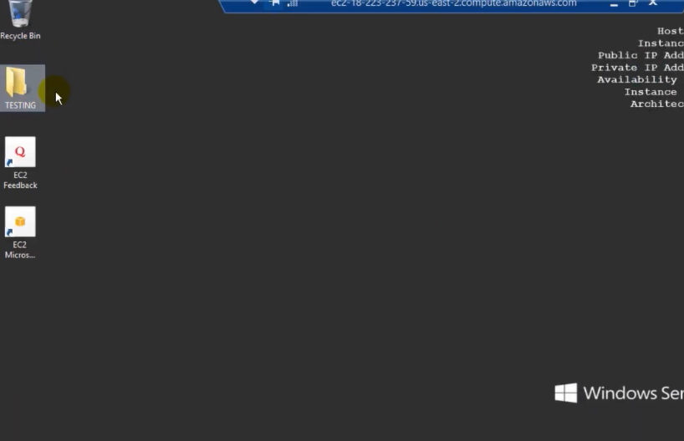

Here i created a folder TESTING and minimize the server.

12.In this step we are going for the take snapshot

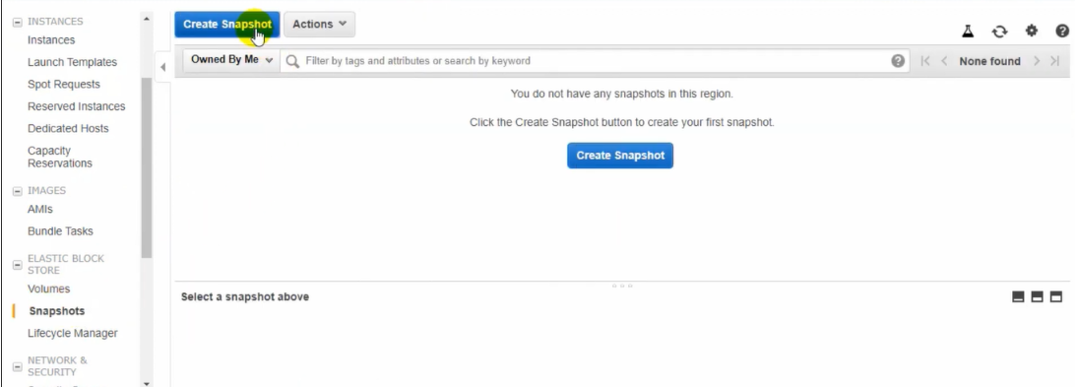

13.In this step i select instance snapshot, select instance id and included root too of our running instance.

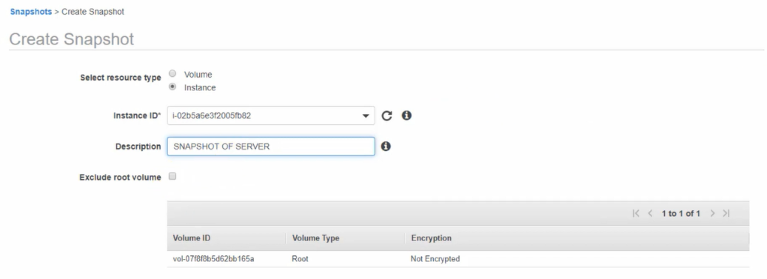

14.I successfully create snapshot .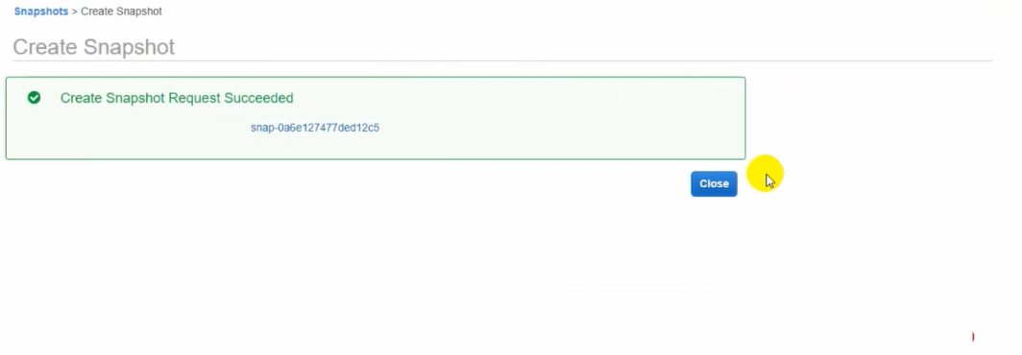

15. Now i am terminated the instance and going to launch another instance.

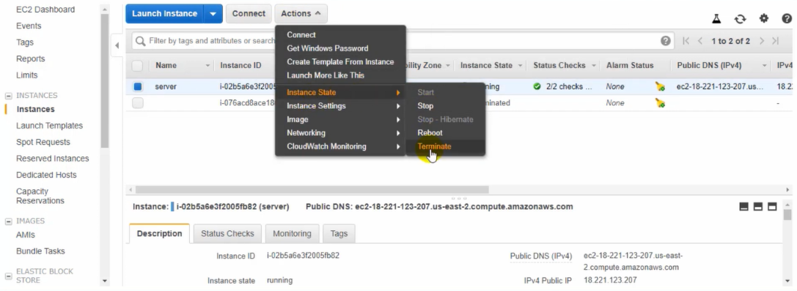

16. In this step i go for create a volume with the help of snapshot .

1. Select snapshot
2. Action
3. Create volume

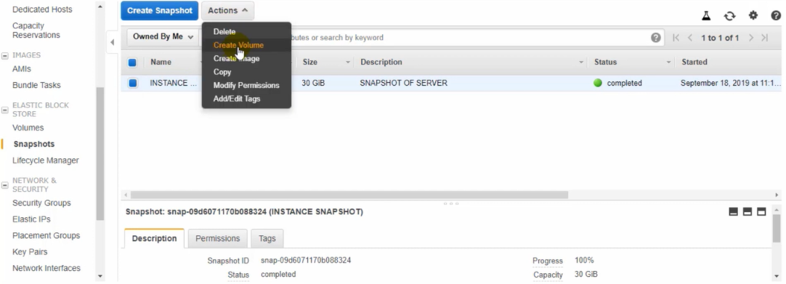

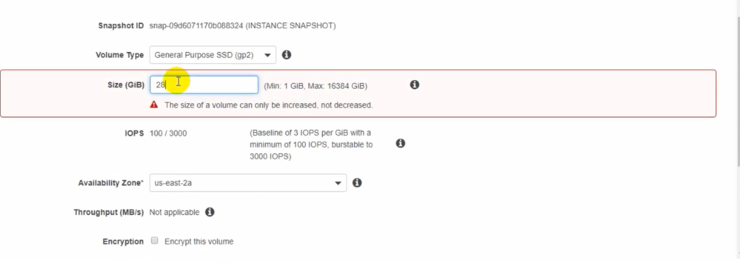

Here we configure volume i chosen general purpose and size 30gb we can extend but never can take less than 30gb because snapshot size has 30gb so we can take 30gb or more tahn 30gb if we are going to take less than 30gb it show error as shown in figure number 2.

17. We can here it successfully created.

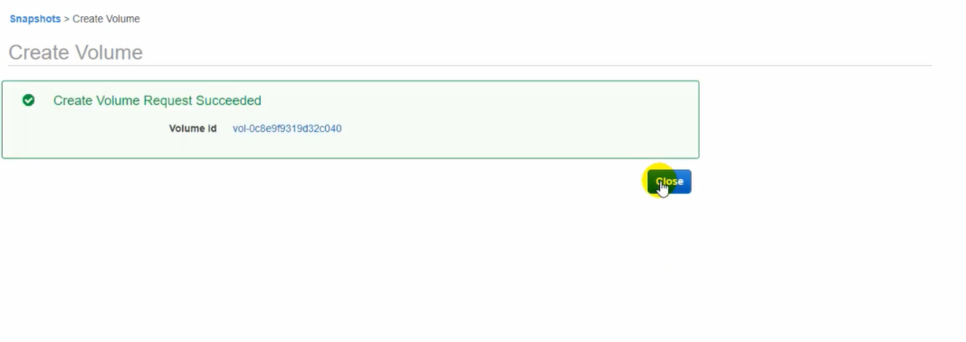

18.

Now we are going to launch another instance and follow same step and same

availability zone.





2.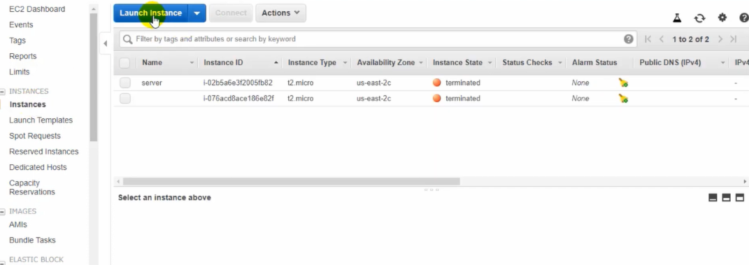

3.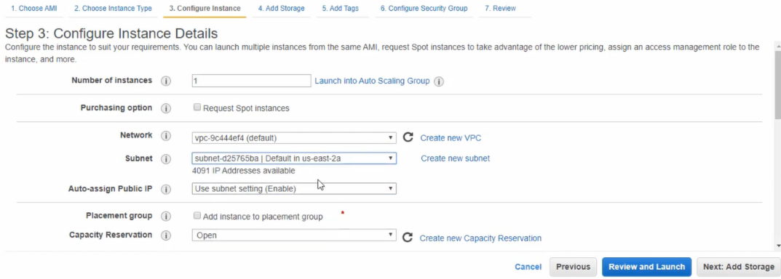

4.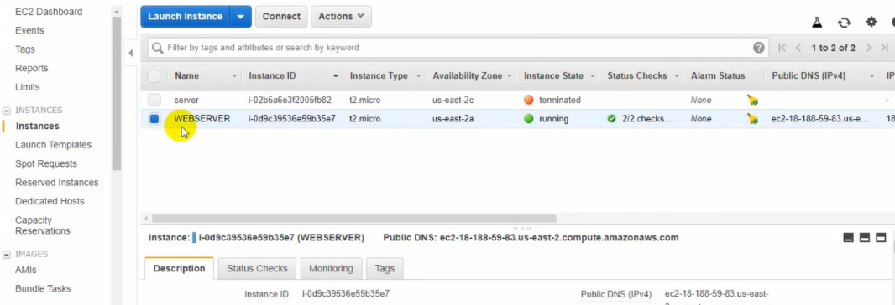

It successfully launched the instance it status shown running and stop the instance to

detach root volume of running instance and attach new volume as a root volume.

19. In this step we can see there are two volume one is used and another one unused

Use volume is attach with instance and another one is snapshot volume as we

Created with the help of snapshot.

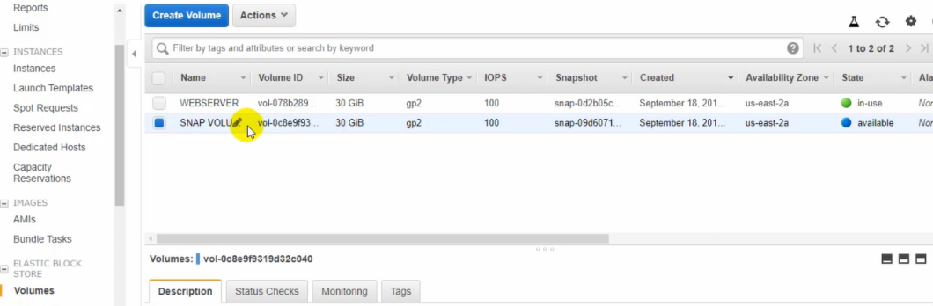

20. Here we are going to detach the instance volume from the running instance without

detach the volume we can’t able to attach the new volume as a root volume to the

instance.

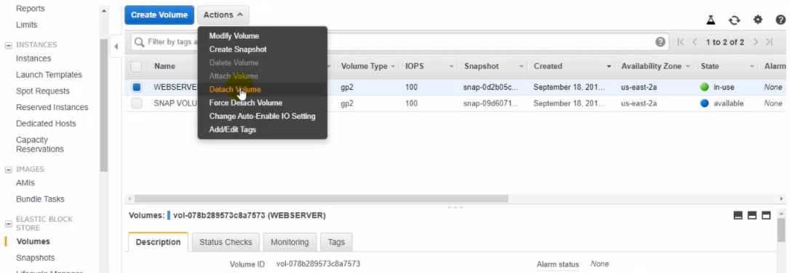

21. Now we can able to attach new volume as a root volume, it by default select the availability zone then choose instance in which we have attach but there is only one instance as we see that is stopped then device path which is very important to put correct path and attach.

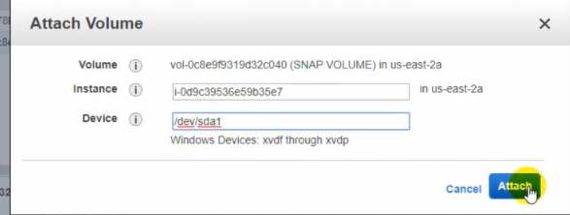

22. Here we can see snapshot volume is shown as in-use it means we successfully attach the another volume as a root volume with the instance.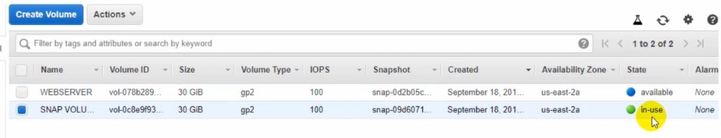

23. Now i can start the instance.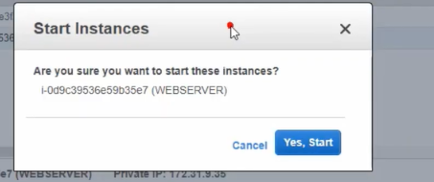

24. Here we go to take RDP click connect.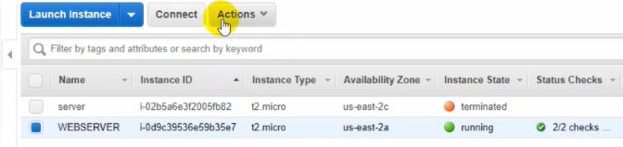

1.

2.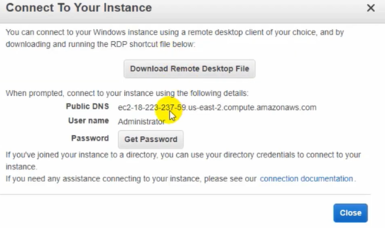

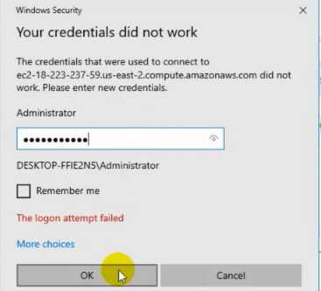

3.

Here put correct password which has first instance otherwise it will show error

and can’t able to connect.

24.It is successfully connect with the server 2012 R2 base and folder as shown on

desktop. 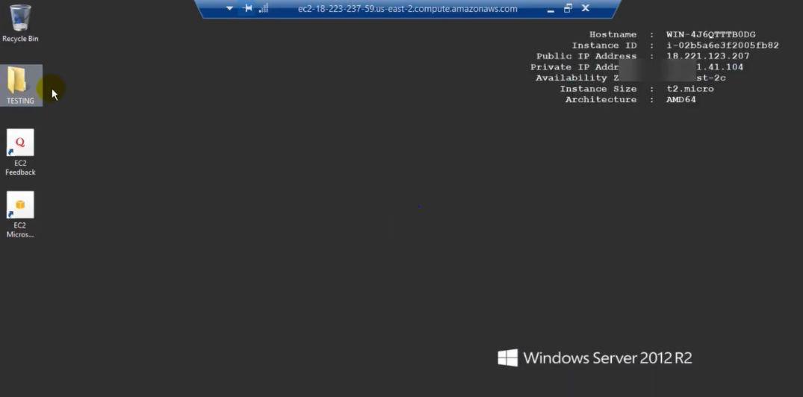

My lab is to detach root volume from running instance and attach new volume as a root volume successfully done.